Virada Games

# Introduction

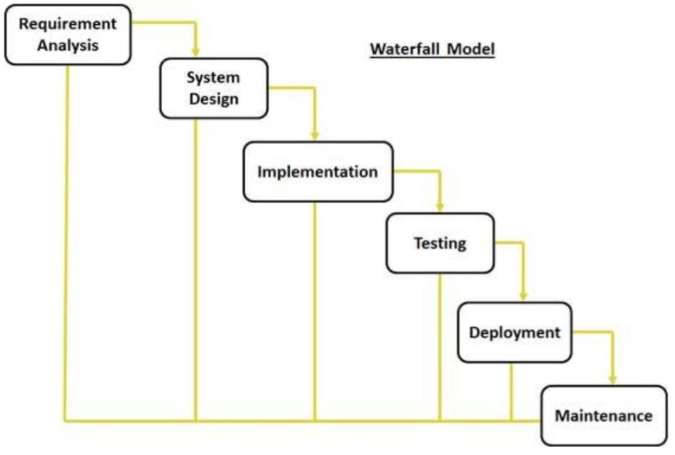This report details the requirements for a POS software for Virada games. The software that is to be developed needs to be able to be track customers’ orders. We are using the Waterfall Model to develop this application as the application as it’s a fairly simple application.

# Analysis: a statement of

* What data items need to be inputted
* What processes need to be performed
* What output is required

Data that needs to be entered is one of three types of Data. Either a Product, Customer or Transaction. The product needs to be one of three type of products a Game, Platform or Accessory.

When

Project plan: a statement of

* List the tasks that need to be performed
* List the job title for each task, when and in what order (UI designer, programmer
* List the physical resources required for each task (PC, software, etc)
* Draw a Gantt chart to show the above information (MS Project or Excel)

Interface design

Programming

Testing

Technical Writer

Design  
I have included a example of reading and writing to an item type these will be the same when reading or writing to the other data files

**Writing Item.dat**

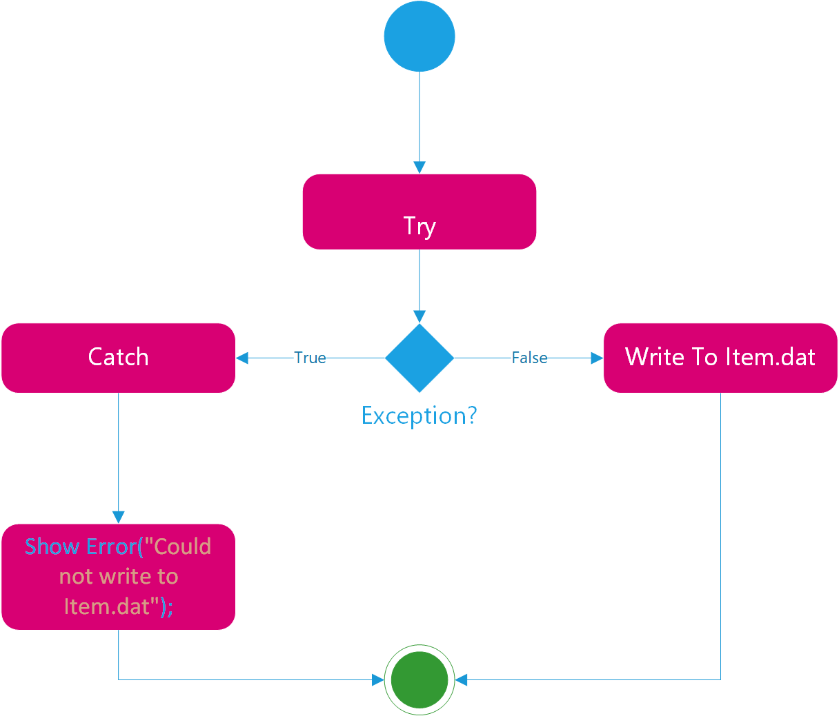

**Reading Item.dat**

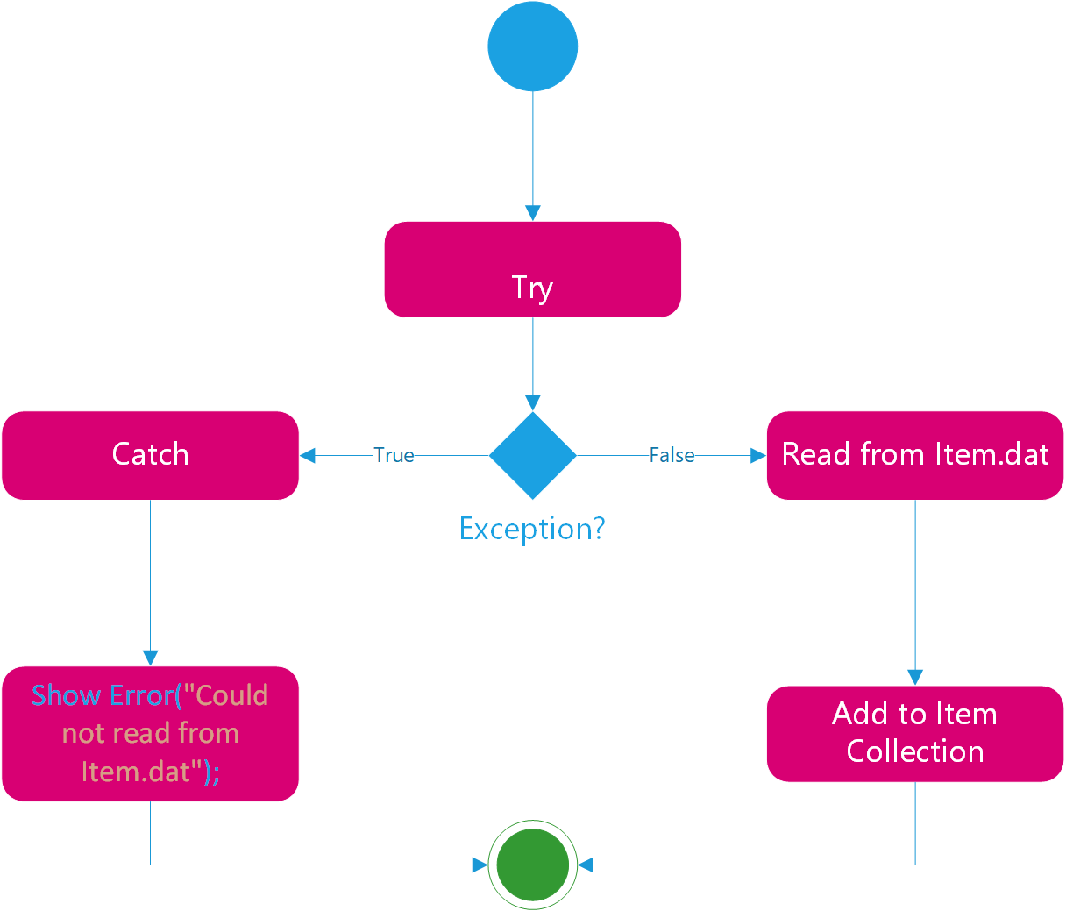

**Add a Customer**

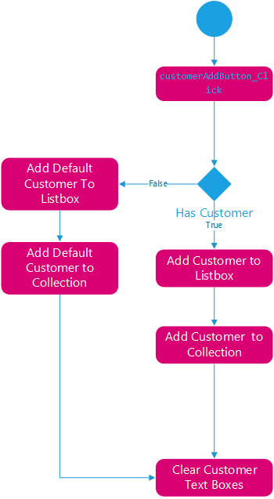

**Add a Transaction**

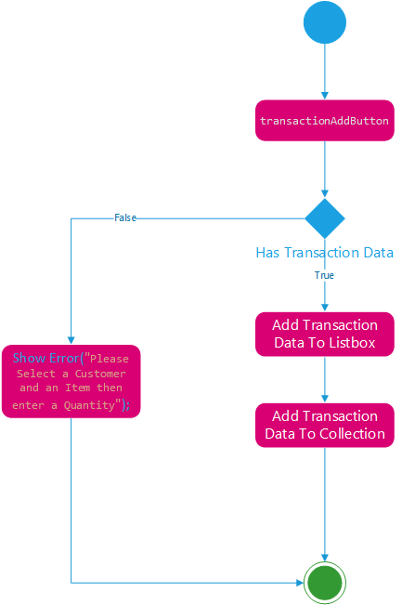

**Add a Product**

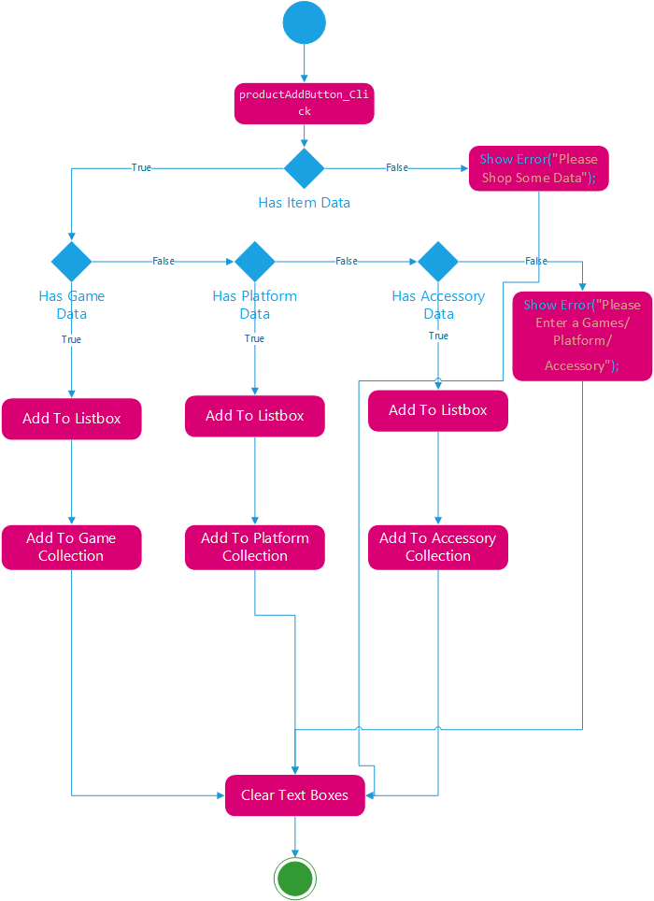

Class Diagram

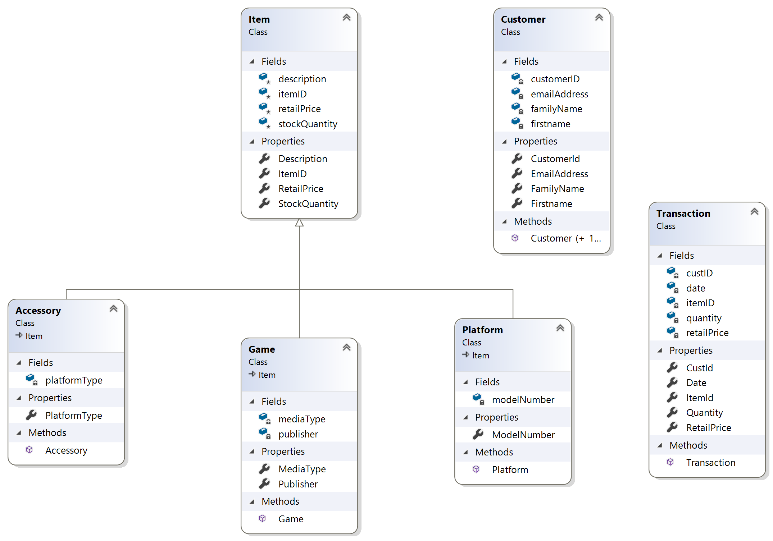

Test Data  
o The data and activities that will be used to test the design. Include the test table

• Testing Evidence  
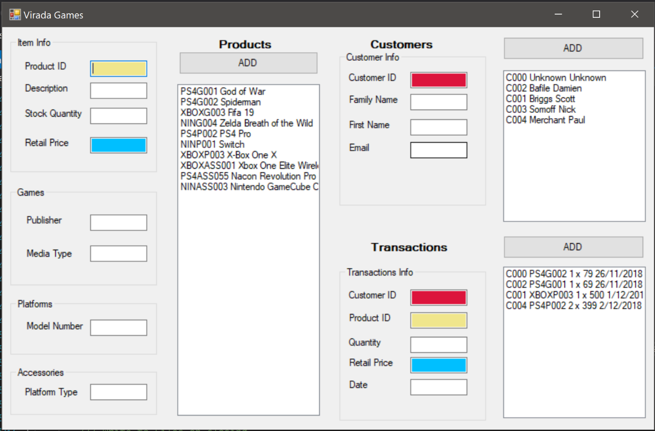  
• Code  
o A reference to the code (the first line of the method and associated comment)